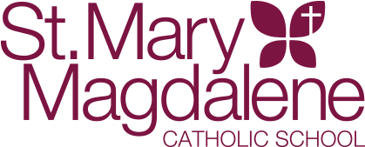

2026 – 2027 BOYS BASKETBALL INFORMATION SHEET

Boys Varsity 2-Time Defending League Champions!!! (7th and 8th graders)
Head Coach: Mr. Joel Groelle
Email: groelle@stmm.net

Boys Junior Varsity (6th and 7th graders)

Head Coach: Mr. David Blaha
Email: blaha_d@yahoo.com

Tryouts: Scheduled for 1st week of November

Season: Varsity November through mid-February
Conference (TCSAC) and non-conference games
End of Season Playoffs (top 4 conference teams)
Shamrock Tournament in Charlotte

JV November through end of January
Conference (TCSAC) and non-conference games
No end of season playoffs

Pre-season Open Gyms: To be scheduled in October
Dates and Times will be published in
School newsletter and posted on School calendar

